**Nama : Allan Wydianto**

**Kelas : FWD Batch 4**

**Github : https//github.com/w1shm3luck/mini-project**

Menyelesaikan beberapa soal menggunakan dummy data

1. 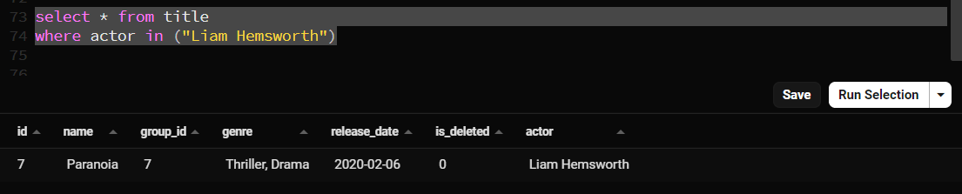Create Query to show list of actor Paronia

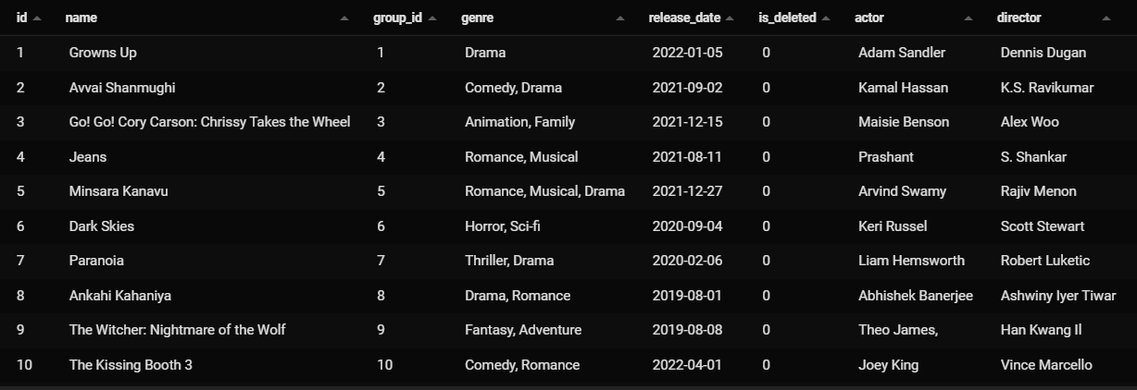2.Create a query to show lis of movie tile with it directors name

1. Create query to show list of the nationality of the movies director and how many movie came from the nation

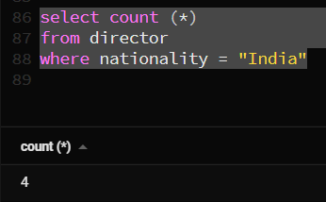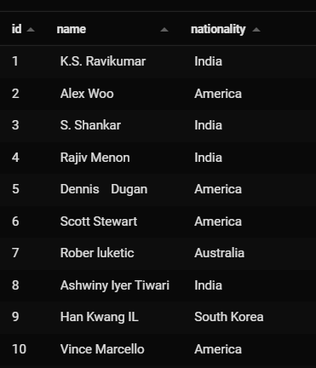

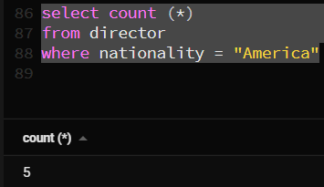

1. 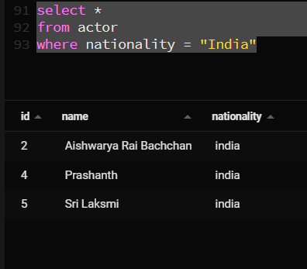Create a query to show all actor and director from india

